**Semester 1 (Unit 3) Examination, 2019**

**Question/Answer Booklet**

**MATHEMATICS APPLICATIONS**

**Section One: Calculator-free**

Student Name/Number: ______________________________________________

Teacher Name: ______________________________________________

**Time allowed for this section**

Reading time before commencing work: five minutes

Working time for this section: fifty minutes

**Materials required/recommended for this section**

**To be provided by the supervisor:** This Question/Answer Booklet

Formula Sheet

**To be provided by the candidate:**

Standard items: pens (blue/black preferred), pencils (including coloured), sharpener,

correction fluid/tape, eraser, ruler, highlighters

Special items: nil

**Important note to candidates**

No other items may be taken into the examination room. It is **your** responsibility to ensure that you do not have any unauthorised notes or other items of a non-personal nature in the examination room. If you have any unauthorised material with you, hand it to the supervisor **before** reading any further.

**Structure of this paper**

|  |  |  |  |  |  |
| --- | --- | --- | --- | --- | --- |
| Section | Number of questions available | Number of questions to be answered | Working time (minutes) | Marks available | Percentage of exam |
| Section One: Calculator-free | 6 | 6 | 50 | 50 | 35 |
| Section Two: Calculator-assumed | 12 | 12 | 100 | 100 | 65 |
|  | | | | | 100 |

**Instructions to candidates**

1. The rules for the conduct of School exams are detailed in the *_______________________________________School/College assessment policy*. Sitting this examination implies that you agree to abide by these rules.
2. Write your answers in this Question/Answer booklet preferably using a blue/black pen. Do not use erasable or gel pens.
3. You must be careful to confine your answer to the specific question asked and to follow any instructions that are specified to a particular question.
4. Show all your working clearly. Your working should be in sufficient detail to allow your answers to be checked readily and for marks to be awarded for reasoning. Incorrect answers given without supporting reasoning cannot be allocated any marks. For any question or part question worth more than two marks, valid working or justification is required to receive full marks. If you repeat any question, ensure that you cancel the answer you do not wish to have marked.
5. It is recommended that you do not use pencil, except in diagrams.
6. Supplementary pages for planning/continuing your answers to questions are provided at the end of this Question/Answer booklet. If you use these pages to continue an answer, indicate at the original answer where the answer is continued, i.e. give the page number.
7. The Formula sheet is not to be handed in with your Question/Answer booklet.

**Section One: Calculator-free 35% (50 Marks)**

This section has **6** questions. Answer **all** questions. Write your answers in the spaces provided.

Supplementary pages for the use of planning/continuing your answer to a question have been provided at the end of this Question/Answer booklet. If you use these pages to continue an answer, indicate at the original answer where the answer is continued, i.e. give the page number.

Suggested working time: 50 minutes.

**Question 1 (7 marks)**

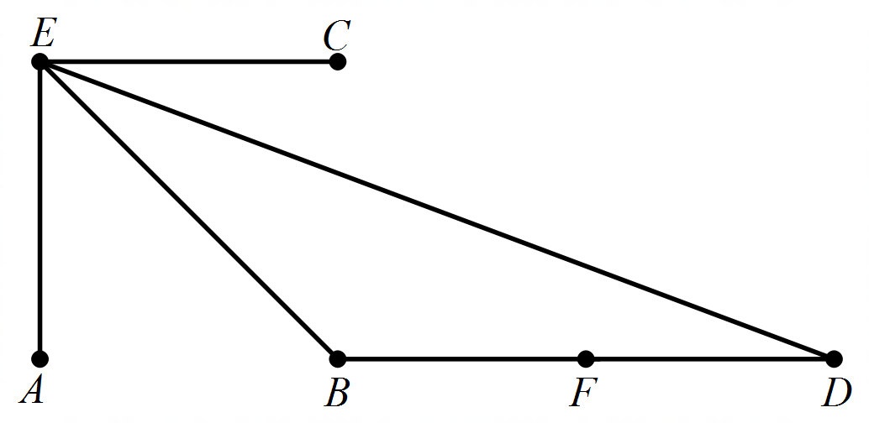

1. What is the sum of the degrees of the vertices? (1 mark)
2. State which edge/s form a bridge (1 marks)
3. Describe a walk which contains five edges and a cycle (2 marks)
4. Re-draw this network as a bipartite graph, clearly showing the two separate groups.

(3 marks)

**Question 2 (9 marks)**

Company ABC commissioned four opinion surveys by two different firms over a period of 7 months following the launch of its new website.The firms were asked to repeat the survey on separate samples. Firm X was commissioned to do surveys one month and 3 months after the launch, while Firm Y commissioned to do the surveys after 5 months and 7 months respectively.

The survey results are provided below. Note: Both firms used a 5-point scale to measure how well liked the website was.

The key used was:

VWL: very well liked, WL: well liked, S: satisfactory, UL: un-liked, VUL: very un-liked

|  |  |  |  |  |  |  |  |
| --- | --- | --- | --- | --- | --- | --- | --- |
|  | **Survey Results** | | | | | | |
|  |  | VWL | WL | S | UL | VUL | Total |
| Firm X | Sample 1X | 7 | 31 | 26 | 16 | 10 | 90 |
| Sample 2X | 22 | 15 | 35 | 10 | 18 | 100 |
| Firm Y | Sample 1Y | 12 | 20 | 17 | **A** | 4 | 60 |
| Sample 2Y | 32 | 52 | 46 | 13 | 7 | 150 |
|  | Total | 73 | 118 | 124 | 46 | 39 | 400 |
|  | Percentage | 18.25% | 29.50% | **B** | 11.50% | 9.75% | **C** |

(a) State an appropriate question which could have been used to collect such data.

(1 mark)

(b) Complete the table by stating the three missing numbers, A, B and C. (3 marks)

The data in the table has been displayed as a divided column graph below.

(c) Using the graph above or another method, comment on:

(i) the association between the ‘Samples’ and the rating ‘Satisfactory’. (1 marks)

(ii) the association between ‘Samples’ and the ratings ‘VWL, WL and S combined’

(2 marks)

The marketing and promotions manager at Company ABC decided that the survey results provided by Firm Y were more reliable than those provided by Firm X.

(d) Do you agree with this decision? Justify your decision. (2 marks)

**Question 3**

**(9 marks)**

  

(a) Use the three adjacency matrices above to answer the following:

(i) Which graph/s contain a loop? (1 mark)

(ii) State which graph has an isolated vertex? (1 mark)

(iii) Which graph is a digraph and what feature of the matrix identifies whether a

graph is directed or not?

(2 marks)

(b) (i) Draw a connected graph with one vertex of order 2, two vertices of order 3 and

two vertices of order 4. (3 marks)

ii) Is this network traversable? Justify your answer. (2 marks)

**Question 4 (6 marks)**

(a) Show that 1 is a term of the sequence defined by  and determine the term that it equates to? (3 marks)

(b) Find the *n*th term of the Arithmetic sequence given . (3 marks)

**Question 5 (11 marks)**

The data provided below was sourced from the website of the The Western Australian Police force and provides the number of crimes committed in two Perth localities over the decade 2007-08 to 2016-2017. A scatter plott of the data is provided next to the numerical data.

|  |  |  |
| --- | --- | --- |
| **Year** | **Suburb A** | **Suburb B** |
| 2007-08 | 3546 | 9489 |
| 2008-09 | 3187 | 9215 |
| 2009-10 | 2087 | 7176 |
| 2010-11 | 1918 | 5941 |
| 2011-12 | 1834 | 6043 |
| 2012-13 | 1733 | 6311 |
| 2013-14 | 1819 | 8616 |
| 2014-15 | 1932 | 6473 |
| 2015-16 | 2162 | 7200 |
| 2016-17 | 2445 | 7808 |

(a) Describe the strength of the linear relationship between the number of crimes in the two suburbs for the specified decade. Interpret what this means. (3 marks)

One of the data points in the graph has been circled.

(b) Which year does the circled data point represent? Interpret the information conveyed by this data point relative to the rest of the data. (2 marks)

(c) Three estimates are given for the correlation coefficient: 0.4 0.6 0.8

Which of these three values is the best estimate? Justify your selection. (2 marks)

(d) It is known that the number of crimes committed in Suburb A during the 2017-18 year is 3010. Use the graph (or model) to predict the number of crimes likely to have been committed in Suburb B during the same year. (2 marks)

(e) Describe the reliability of the prediction that you made in part (d) and justify your conclusion. (2 marks)

**Question 6 (8 marks)**

The value of Matt’s famous Heysen painting, on any given year since it was purchased, follows the Geometric sequence, , where  is the value in the *n*th year. The values in the first and third year are displayed graphically below.

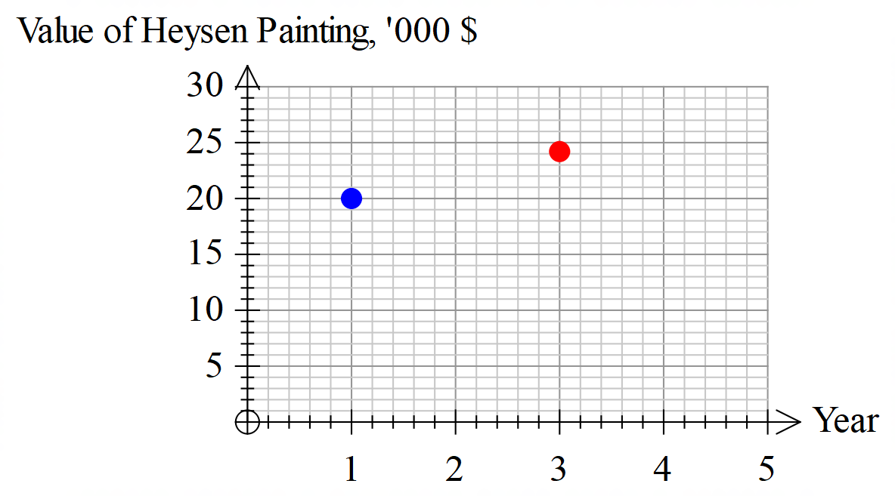

(3,24.2)

(a) Use the data supplied to complete the table below.

(a) Show how the common ratio of the geometric sequence is calculated. (2 marks)

(b) Describe the change in the value of Matt’s painting during the first four years.

(2 marks)

(c) Add the missing data points for the 2nd and 4th year. (2 marks)

(d) Write the geometric sequence rule  as a recursive equation.

(2 marks)

**End of Questions**

Additional working space

Question number: __________________

Additional working space

Question number: __________________

© MAWA, 2018

This examination is Copyright but may be freely used within the school that purchases this licence.

* The items that are contained in this examination are to be used solely in the school for which they are purchased.
* They are not to be shared in any manner with a school which has not purchased their own licence.
* The items and the solutions/marking keys are to be kept confidentially and not copied or made available to anyone who is not a teacher at the school. Teachers may give feedback to students in the form of showing them how the work is marked but students are not to retain a copy of the paper or marking guide until the agreed release date stipulated in the purchasing agreement/licence.

*Published by The Mathematical Association of WA*

*12 Cobbler Place, MIRRABOOKA 6…*